Instructions on adding speech to a video

Steps:
1. Get a video.
2. Convert into format that can be import into video studio.
3. Split the audio.
4. Record your own voices.
5. Add any special effect that you wanted.

Step 1:
Get a video:
Where? E.g. Youtube? How?

Suggestion:
Ask www.google.com.hk
Give a suitable searching sentence:
- How to download youtube movie;
- Download youtube movies online;

Some Solutions I got :
download from
- http:// KeepVid.com
- http://vixy.net/
- http://www.savetube.com/
- add kiss in front of the youtube URL

Step 2:
Can the video imported into Video studio?
Note: There are thousands of video format: wmv, avi, mp4, rmvb etc., VideoStudio does not support youtube movie which is .flv

If the answer is
- Yes! Good!
- No! Get another one or convert the video into another format

Suggested solution
Ask www.google.com.hk
suggestion: free video converter

The school download the freeware: Any video converter
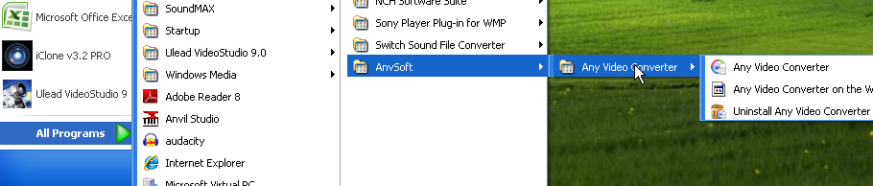

Step 1: Set the output to the one you wanted e.g. wmv

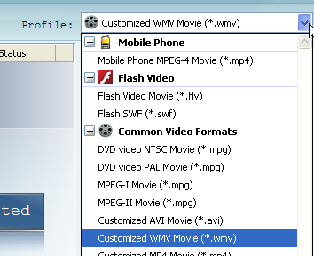
Step 2: Follow the steps:
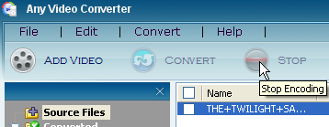
After finished: Click” No Thanks! “ or else have to pay
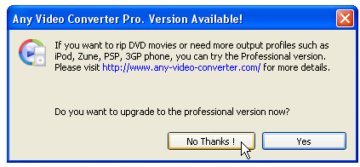
The converted file saved at
if you are using wmv format
Step 3 , 4:
Split the audio.
Have a look on the PowerPoint in the web site

Hint:
Try to record short speech (One sentence each!)

You may drag the location of the audio 
Change the speed a little bit
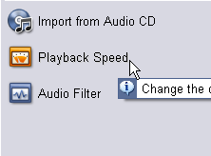 | 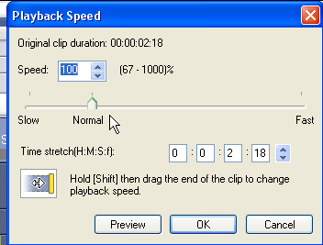
to suit the video

